Ex:No: 14

Date: 29/01/2023

**HIGH LEVEL PROGRAMMING EXTENSIONS**

**(PROCEDURES)**

**Program 1:**

Create a simple procedure to get all the records from the table ‘student_info’ which have the following data:

|  |  |  |  |  |
| --- | --- | --- | --- | --- |
| mysql> select * from student_info; | | | |  |
| +----- | +--------- | +------------ | +------------ | + |
| | id | | Name | | Address | | Subject | | |
| +----- | +--------- | +------------ | +------------ | + |
| | 100 | Aarav | | | Delhi | | Computers | | |
| | 101 | YashPal | Amritsar | History | | | | | |
| | 105 | Gaurav | Jaipur | | | | Literature | |  |
| | 110 | Rahul | | | Chandigarh | History | | | |
| +------ | +-------- | +------------ | +------------ | + |

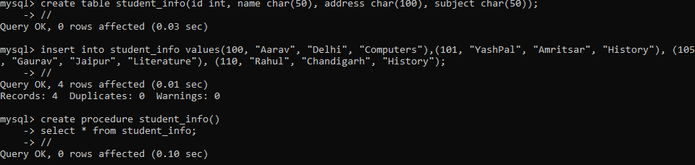

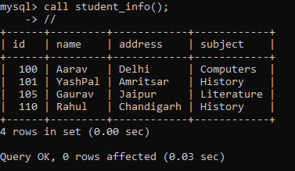

**Program 2:**

Create a stored procedure GetCustomerLevel() that accepts two parameters customer number and customer level.

  First, it gets the credit limit from the customers table. 

Then, based on the credit limit, it determines the customer level: PLATINUM , GOLD , an SILVER. 



The parameter p_customerlevel stores the level of the customer and is used by the calling program.

The following flowchart demonstrates the logic of determining customer level.

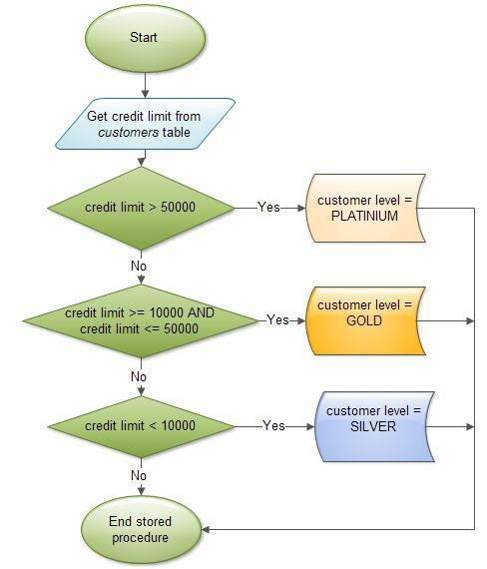

The table ‘customers’ should have the following attributes:

customers(cno , cname, creditlimit)

